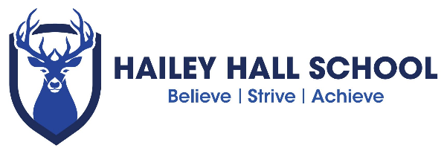

C O M P U T I N G R O U T E S
S U B J E C T P A T H W A Y S

C A R E E R S

Nearly all jobs require some IT skills so this subject can be useful no matter you do after school. Many (though not all) careers directly related to computer science need higher education (and sometimes post graduate) qualifications. Computer science, information technology, computing, engineering, maths, sciences or business management systems are just some of the higher education courses available. Some other degree subjects are acceptable too if you have the right skills. Check the entry
requirements for each career.

AI software developer Business analyst Computer games designer
Computer service technician Data analyst
Database administrator E-learning developer
Face recognition developer Games developer
Helpdesk adviser Information security analyst
Information systems manager IT consultant
IT project manager
IT sales consultant IT systems architect IT technician
IT trainer
Multimedia programmer Network engineer Robotic scientist
Search engine optimiser Software engineer Systems analyst Systems developer Teacher/lecturer Technical author
User experience (UX) analyst Web developer

S K I L L S

Studying computer science can also help you develop wider skills such as:

Accuracy
Analysis and reasoning Attention to detail Communication Creative thinking
IT
Logical thinking

Organising Problem-solving Report writing Teamwork
Time management Using numbers Working independently

These skills are needed for many jobs at different levels and with a range of entry routes, including apprenticeships and further or higher education. Here’s a selection:

Accountant Accounting technician Administrative assistant Archivist
Cartographer
Customer services assistant Data entry clerk
Digital marketing officer Electrician
Financial adviser Indexer
Information scientist Librarian
Library assistant Media researcher
Motor vehicle technician Office equipment technician Office manager
Payroll clerk Retail manager Sales assistant
Social media manager Switchboard operator Telecoms technician Warehouse assistant Web writer

D I D Y O U K N O W ?

The first computers were so large, they took up a whole room but now some of them are no bigger than a grain of rice!

R O U T E S

There are different routes into many careers, including full-time study, higher education and apprenticeships. Whichever route you choose, you will probably need good grades in English and maths.

Higher and degree apprenticeships are being developed in digital technologies. These should offer university-level study while you work and earn a wage.

You may need maths at A Level or equivalent to study computer science at university. Higher education courses in subjects such as computing or IT may have more flexible requirements or you can sometimes follow a foundation year if you don’t have the right subjects. Make sure you do your research as there are many different course titles. Some higher education courses have similar names but different content and teaching methods. This is a fast-moving sector so you will need to update your skills throughout
your career.

F I N D O U T M O R E

For more job ideas, visit nationalcareersservice.direct.gov.uk/youngpeople then follow links to ‘Aged 13-19’ and ‘Do something you’re good at’.

If you’re thinking about higher education, visit: www.prospects.ac.uk to see what art and design graduates have done after their degree.

Hailey Hall Careers lead
Peter Gregory – pgregory@haileyhall.herts.sch.uk

School independent Career advisors
Coral Thomas ( Hertfordshire students ) -Coral.Thomas@Hertfordshire.gov.uk
Laura Todd ( Essex students )-Laura.Todd@essex.gov.uk

Other websites thetechpartnership.com creativeskillset.org sheffieldfutures.org.uk ucasprogress.com ucas.com
icould.com

