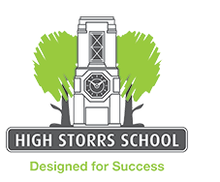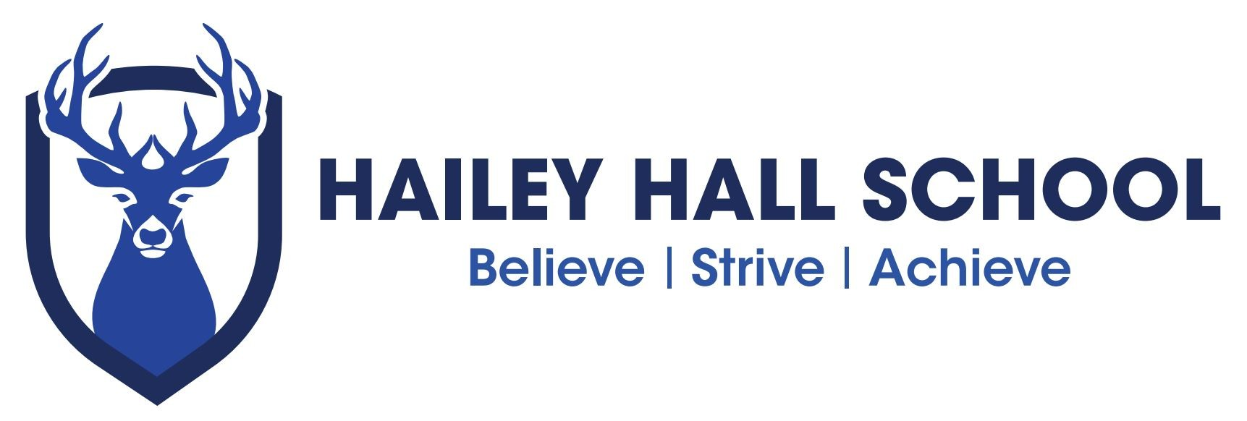

F I L M A N D M E D I A R O U T E S

S U B J E C T P A T H W A Y S

C A R E E R S

Media studies can develop skills and knowledge that will be useful in a range of jobs, such as:

Advertising account executive Agent
Arts officer Blogger/vlogger Brand manager
Business development manager Commissioning editor Copywriter
Creative director
Creative media consultant Digital communications officer Digital content editor
Digital designer
Digital marketing manager Digital planner
Director - TV / film / video Distributor
Editorial assistant Events manager Floor runner Image consultant
Information officer
Journalist/reporter Market researcher Marketing officer Media buyer
Media planner Multimedia manager News editor Presenter – TV/radio Producer
Production assistant Programme researcher Promotions manager Public relations officer Publicist
Search engine optimiser Social media listening officer Social media manager Teacher/lecturer/tutor
UX (user experience) designer Video content creator
Video editor Videographer
Web developer/writer

However, if you’re not taking media studies, it doesn’t mean you couldn’t get into these jobs. Other subjects are important too so check the entry requirements for each career.

S K I L L S

Studying Film & Media can also help you develop wider skills such as:

Analysis and reasoning Business awareness Communication Creativity
Critical thinking Decision-making Evaluation Flexibility
IT
Organising and planning Practical
Presentation Problem-solving Research Teamwork
Time management Writing

These skills are needed in a range of jobs although you may need other subjects too:

Administrator Bid writer
Bookings assistant Buyer
Civil service officer Contract manager Fundraiser
Games Developer
Librarian/library assistant
Logistics manager Merchandiser Proofreader Recruitment consultant Research assistant Retail display worker Retail manager
Sales assistant/director Telephone sales executive

D I D Y O U K N O W ?

Some of these careers didn’t even exist ten years ago! The sector changes all the time so be sure to keep your skills up to date.

R O U T E S

Routes into these careers include further education courses, apprenticeships and higher education. Degree and higher apprenticeships are recently on the scene and combine a job with university study. Many of these jobs (particularly in digital media) are relatively new so the routes are sometimes more flexible than they are for a traditional career.

You may need other subjects too, particularly English. Maths is always important.

Higher education courses in media studies vary. Some are highly practical while others are more academic and others offer a mix. Be sure to do your research! You don’t normally need to have studied the subject before.

Jobs in the creative and digital media sector are often short term so you need a good network of contacts and up-to-date skills. A recent report* revealed that almost one in three workers in the sector were freelance. 78% are reported to have degrees but only around half in a creative / media subject. Many had done unpaid work experience when starting.

The creative and digital industries are seen as very important to this region but there can be jobs with all types of companies e.g. helping an organisation make better use of social media

F I N D O U T M O R E

For more job ideas, visit nationalcareersservice.direct.gov.uk/youngpeople then follow links to ‘Aged 13-19’ and ‘Do something you’re good at’.

If you’re thinking about higher education, visit: www.prospects.ac.uk to see what art and design graduates have done after their degree.
Hailey Hall Careers lead
Peter Gregory – pgregory@haileyhall.herts.sch.uk

School independent Career advisors
Coral Thomas ( Hertfordshire students ) -Coral.Thomas@Hertfordshire.gov.uk
Laura Todd ( Essex students )-Laura.Todd@essex.gov.uk

Other websites ccskills.org.uk creativeskillset.org ucasprogress.com ucas.com
icould.com bbc.co.uk/careers shiftmedia.org.uk gov.uk/apply-apprenticeship

