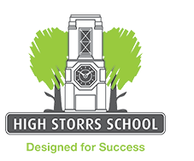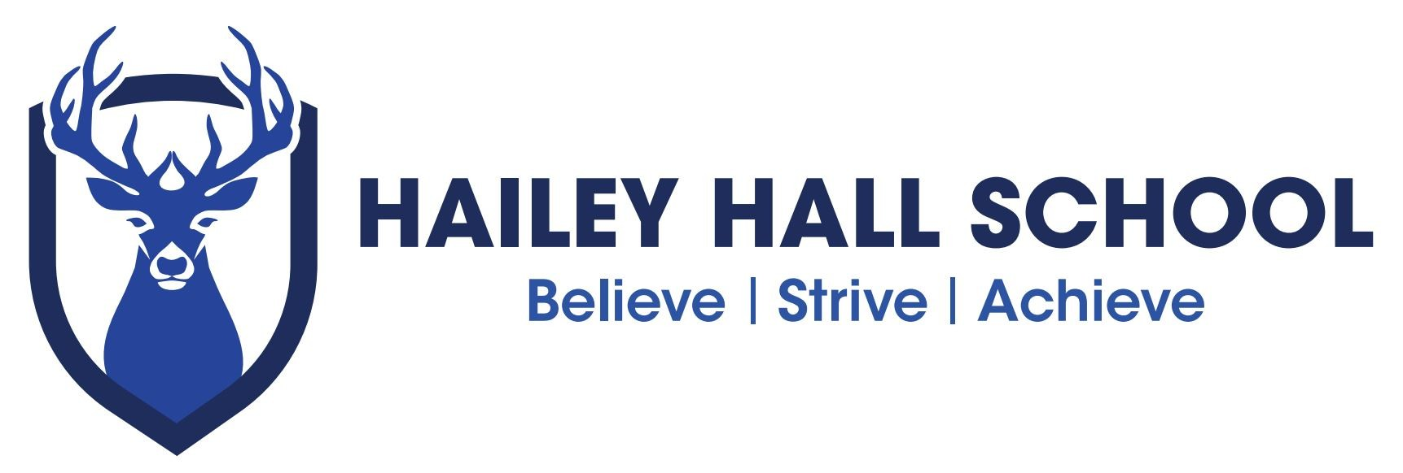

E N G L I S H R O U T E S
S U B J E C T P A T H W A Y S

C A R E E R S

Many careers that are directly related to English require higher education and sometimes postgraduate qualifications. They include

Commissioning editor Copywriter/editor Editorial assistant

English as a foreign language teacher Journalist
Lecturer
Lexicographer School teacher

English is important for most jobs but particularly for any that need good spoken and written skills. Here’s a selection:

Advertising account executive Arts administrator
Barrister
Blogger/vlogger Bookseller Broadcaster
Digital marketing manager Film / TV editor Information officer
Legal executive
Librarian/library assistant Market researcher

Marketing assistant Media researcher Proofreader
Public relations officer Research assistant Social media manager Solicitor
Speech therapist
TV production assistant TV researcher
Web content manager Web editor

There are different routes into these careers, including higher education and, in some cases, apprenticeships.

S K I L L S

Studying English can also help you develop wider skills such as:

Communication Creativity Critical thinking
Information handling Negotiation Organization
Presentation Research Teamwork Using IT
Time management
Understanding other points of view Working independently

These skills are important for many jobs at different levels and with a range of entry routes, including apprenticeships and further or higher education. Here’s a selection:

Administrative/clerical assistant Care home manager
Care worker Charity fundraiser Civil service officer
Customer services assistant Human resources manager Nurse
Occupational therapist
Personal assistant Police officer Retail buyer
Sales assistant Sales director Social worker
Social work assistant Telephone sales

D I D Y O U K N O W ?

Sheffield MP Angela Smith studied English at university, as did the actress Emma Watson, TV presenter Clare Balding and MPs Andy Burnham and Caroline Lucas.

Many English graduates enter careers that aren’t directly related to the subject. Some have gone on to be chief executive of companies such as Walt Disney, Avon, Hewlett Packard and YouTube!

R O U T E S

Many jobs require at least GCSE grade A*-C / 9-4 in English.

There are different routes into many careers, including full-time study, higher education and apprenticeships.

If you want to write, you can use digital media (e.g. blogs, fan fiction or electronic publishing) to improve your craft and reach an audience. Keeping up with new technology will help you make the most of other new opportunities. Freelance work and short contracts are commonplace so you need good business sense and a network of contacts. There are courses in creative writing, including degrees and postgraduate
study but these aren’t essential

F I N D O U T M O R E
For more job ideas, visit nationalcareersservice.direct.gov.uk/youngpeople then follow links to ‘Aged 13-19’ and ‘Do something you’re good at’.

If you’re thinking about higher education, visit: www.prospects.ac.uk to see what art and design graduates have done after their degree.

Hailey Hall Careers lead
Peter Gregory – pgregory@haileyhall.herts.sch.uk

School independent Career advisors
Coral Thomas ( Hertfordshire students ) -Coral.Thomas@Hertfordshire.gov.uk
Laura Todd ( Essex students )-Laura.Todd@essex.gov.uk

Other websites ccskills.org.uk creativeskillset.org .org.uk ucasprogress.com ucas.com
icould.com bbc.co.uk/writersroom
www2.le.ac.uk/offices/english-association writersandartists.co.uk nationalcareersservice.direct.gov.uk

