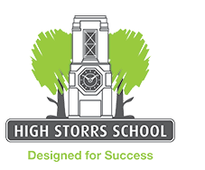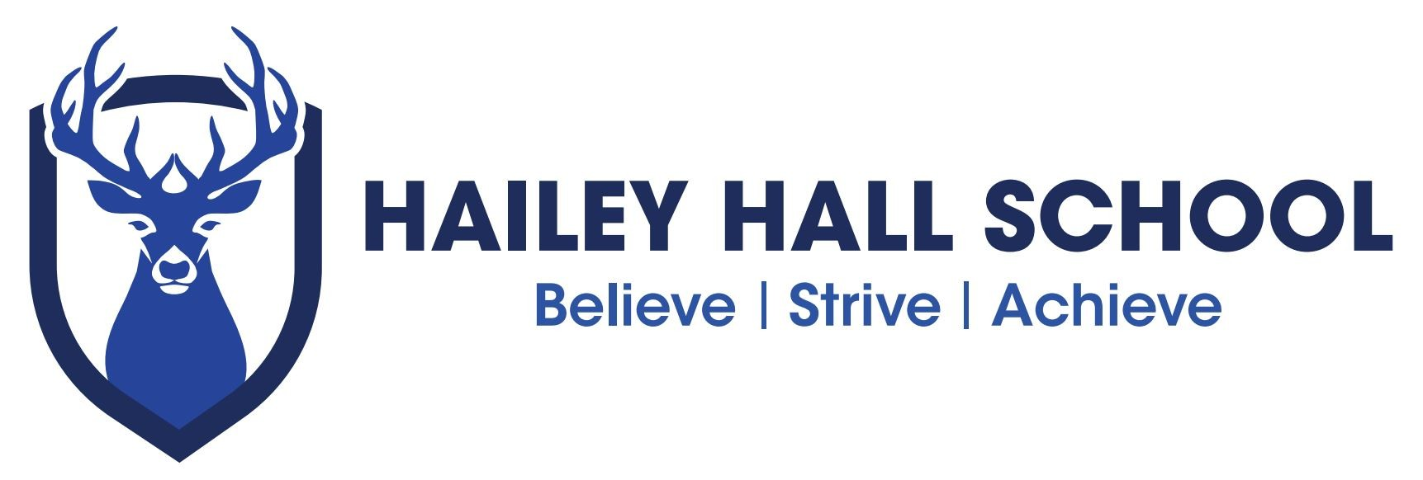

B I O L O G Y R O U T E S
S U B J E C T P A T H W A Y S

C A R E E R S

Many careers directly related to biology need higher education - and sometimes postgraduate - qualifications in either biology or a related subject.

Biomedical scientist Biotechnologist Conservation scientist Higher education lecturer
Microbiologist Pharmacologist Secondary school teacher Soil scientist

There are many jobs where biology is helpful or preferred although there may be other requirements too, e.g. in chemistry, maths, other sciences and English. They include:

Agricultural inspector Ambulance paramedic Animal care worker Dental hygienist Dental nurse
Dental technician Dentist
Dispensing optician Doctor
Environmental health officer Food technologist
Forensic scientist Healthcare assistant
Laboratory technician Medical sales representative Medical secretary/receptionist
Midwife Nurse
999 Call handler Occupational therapist Operating department practitioner Optometrist Pharmacist Phlebotomist
Physiotherapist Podiatrist
Prosthetist / Orthotist Radiographer Scientific journalist Speech & language therapist
Sports scientist
Sterile services technician Veterinary nurse Veterinary surgeon

S K I L L S

Studying biology can help you develop wider skills such as:

Analytical Attention to detail Communication Critical thinking Data handling
IT
Organising/planning
Practical / using equipment Problem solving
Research Teamwork
Time management Using numbers Working independently

These skills are needed for many jobs at different levels and with a range of entry routes. Here’s a selection:

Accountant Accounting technician Beauty therapist
Care assistant Chef
Customer services assistant Fitness instructor
Florist Hairdresser
Hospital porter Horticultural worker Human resources manager ICT helpdesk advisor Police officer
Receptionist Recycling officer Retail manager Sales representative

D I D Y O U K N O W ?

Many biology graduates go into careers outside of science or health, including business, finance and marketing.
Human beings share about 99% of their DNA with chimpanzees and bonobos – and about 50% with a banana!

R O U T E S

There are different routes into many careers, including full-time study, higher education and apprenticeships.

You must stay in learning until age 18. This can be in full-time study, an apprenticeship or other job with training or a work-based learning programme such as a traineeship.

You may need other subjects alongside biology, particularly maths, English and other sciences such as chemistry and/or physics.

F I N D O U T M O R E

For more job ideas, visit nationalcareersservice.direct.gov.uk/youngpeople then follow links to ‘Aged 13-19’ and ‘Do something you’re good at’.

If you’re thinking about higher education, visit: www.prospects.ac.uk to see what art and design graduates have done after their degree.

Hailey Hall Careers lead
Peter Gregory – pgregory@haileyhall.herts.sch.uk

School independent Career advisors
Coral Thomas ( Hertfordshire students ) -Coral.Thomas@Hertfordshire.gov.uk
Laura Todd ( Essex students )-Laura.Todd@essex.gov.uk

Other websites: ccskills.org.uk screenskills.com/
nationalcareersservice.direct.gov.uk ucasprogress.com
ucas.com

