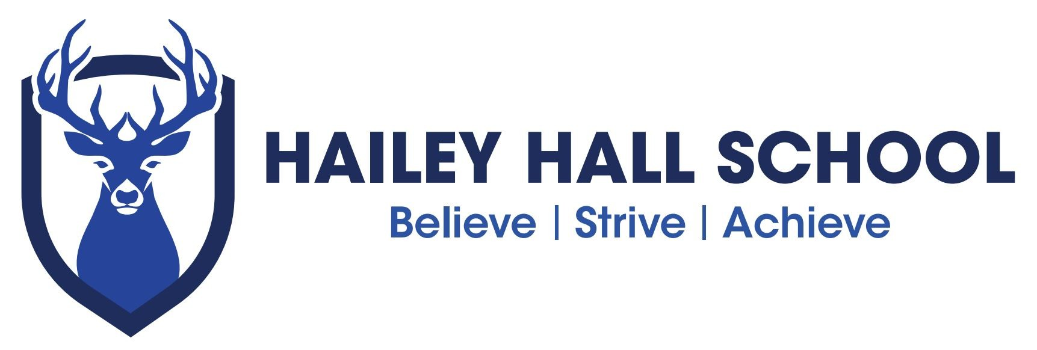

A R T R O U T E S
S U B J E C T P A T H W A Y S

Careers
Many (although not all) careers related to art and design require
higher education qualifications. They include:
Advertising account manager
Advertising art director Animator
Antiques dealer Architect
Art gallery curator Art therapist
Arts administrator Arts education officer Auctioneer / valuer
Audio visual technician Cinematographer Community arts worker Costume designer Conservator
Design engineer Exhibition designer
Fashion buyer
Fashion designer Fashion retailer Film producer Fine artist Furniture designer
Gallery education officer Gallery assistant
Games designer Graphic designer Illustrator Interior designer
Jewellery designer Landscape designer Medical Illustrator Museum education officer photographer
Product Designer Set Designer Silversmith Teacher/lecturer Textile designer User Interface (UI) designer
Visual effects (VFX) producer
Web designer
Some of the creative industries are also developing apprenticeships.

S K I L L S

Studying art and design can help you develop wider skills, such as:

Attention to detail Communication Creativity
Critical thinking IT
Organising/planning Practical Presentation

Problem-solving research
teamwork
Time management
Using tools and equipment Visual/spatial awareness Working independently

These skills are needed for many jobs at different levels and with a range of entry routes, including apprenticeships and further education. Here’s a selection:

Architectural technician Beauty therapist
Body piercer
Cake decorator / confectioner Carpenter / joiner Chef
Civil engineering technician Digital marketing manager Display assistant
Engraver Florist
Furniture maker Hairdresser
Image consultant Machine printer Make-up artist
Marketing manager/assistant technician
Painter & decorator Plasterer
Public relations officer Retail buyer
Retail display worker Retail jeweller Signwriter
Tattooist

D I D Y O U K N O W ?

James Dyson, the inventor and founder of the Dyson Company, studied furniture and interior design before moving into engineering.

Florence Welch and Jarvis Cocker are also former art / design students.

R O U T E S

It’s important to back up art and design with other subjects. English and maths are required for most careers and, depending on the job, you may also need sciences and sometimes a language or history.

Many creative careers don’t follow a conventional path. Freelancing and short contracts are common and you will need to build up a good network of contacts to spot opportunities.

Change happens quickly in the creative industries so keep your IT skills up to date. You also need good business sense – artists have to make a living!

If you’re looking into higher education, take care with your research as courses can vary
e.g. some are more practical than others. Some courses want you to follow an 18+ Art Foundation Course first. Many will want to see a selection of your work (called a portfolio).

F I N D O U T M O R E

For more job ideas, visit nationalcareersservice.direct.gov.uk/youngpeople then follow links to ‘Aged 13-19’ and ‘Do something you’re good at’.

If you’re thinking about higher education, visit: www.prospects.ac.uk to see what art and design graduates have done after their degree.

Hailey Hall Careers lead
Peter Gregory – pgregory@haileyhall.herts.sch.uk

School independent Career advisors
Coral Thomas ( Hertfordshire students ) -Coral.Thomas@Hertfordshire.gov.uk
Laura Todd ( Essex students )-Laura.Todd@essex.gov.uk

Other websites: artscouncil.org.uk ccskills.org.uk screenskills.com/
nationalcareersservice.direct.gov.uk ucasprogress.com
ucas.com

