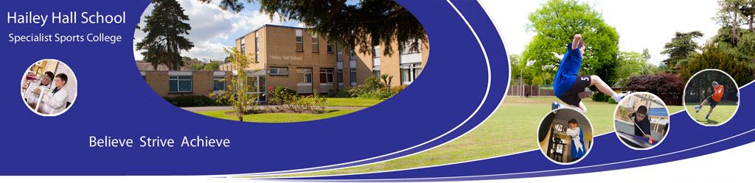

Catch Up Funding for Year 7 Pupils - 2018 Hailey Hall School

What is CaTCH UP Funding?
The Deputy Prime Minister announced in September 2012 that secondary schools will receive funds for each year 7 pupil who did not achieve Level 4 or better at Key Stage 2 in reading and/or Maths. Since the National Curriculum Levels were abolished in 2016, the criteria of level 4 was no longer relevant, so now schools receive the overall funding that they received in 2016/17 adjusted to the percentage change in the current Year 7 cohort.

How Should the Funding be Used and for which pupils?
With the abolition of National Curriculum levels, it is now up to schools to identify which Year 7 pupils are in need to extra help with literacy and numeracy. We look at certain factors to ascertain which pupils are in need of intervention such as looking at the Question Level Analysis for Key Stage 2 in RAISEONLINE’s replacement ASP.

How much did we receive in funding in the academic year 2017-18?
In the Academic Year 2017-18 Hailey Hall School received £5,250 in Catch up Funding.

How Much funding did we receive in the academic year 2016-17 and how did we spend this funding?
In the previous academic year we received £4,500 and these are some ways in which the funding benefitted pupils:
- Smaller groupings for pupils and Outdoor Adventurous activities programme for Year 7s
- The Summer school and transition programme meant staff were able settle pupils more quickly into school, encourage independence, build pupil confidence and meet individual pupil need
- All of the pupils are receiving 1:1 Literacy and Numeracy support to support their learning. They also receiving other interventions to fulfil other needs related to their statement of Special Educational Needs or Education Heath and Care plan.
- Individualised behavioural, emotional and social intervention and Support from form tutor.
- Purchase of resources for the above.
- Support Staff in the classroom.
- After school activities and interventions including motivational activities.
- New books in the library chosen by the pupils that are of interest to them. This has helped to encourage reluctant readers and has supported all pupils of different ages and abilities.
- Additional IT support and network to support pupil learning in class.
- Implementation of the Reading, Spelling and Maths for Purpose programmes carried out during tutor groups. These are monitored by learning walks carried out by members of SLT and Middle management.

How have these pupils progressed in English and Maths? how the catch up funding has made a difference in attainment

Impact of Interventions on Learning
As mentioned previously, National Curriculum levels were abolished and at Hailey Hall School we designed a robust “life without levels” system. Students are given a band from approaching through to Mastering.
Name | Pupil Premium | BME | Progress Eng | Progress Maths | Context
AA | Yes | No | E2-D1 | A3-E2 | 2 sublevels of progress in both subjects
JB | Yes | No | E1-D1 | A2-D1 | 1 whole level progress in English and more than one whole level in Maths
DG | Yes | No | E1-E3 | A2-E2 | 2 sublevels progress in English and one whole level in Maths
JM | Yes | No | E2-E3 | A1-E2 | 1 whole level progress in English and more than one whole level in Maths

Increase in reading and spelling ages
Name | Reading Age on Arrival | Current Reading Age | Difference in Years | Spelling Age on Arrival | Current Spelling Age | Difference in Years | Maths Age on Arrival | Current Maths Age | Difference in Years
AA | 9.5 | 10.5 | 1 | 9.0 | 10.5 | 1.5 | 12.00 | 12.00 | 0.00
JB | 18.00 | 18.00 | 0.00 | 7.5 | 8.5 | 1 | 9.5 | 9.5 | 0.00
DG | 8.5 | 8.5 | 0.00 | 8.5 | 8.5 | 0.00 | 10.00 | 10.5 | 0.5
JM | 18 | 18 | 0.00 | 18 | 18 | 0.00 | 11.5 | 11.5 | 0.00

Impact of interventions on soft skills
At Hailey Hall School, all pupils are awarded points for various categories of learning behaviour; points are awarded at the end of each lesson and are grouped into 3 categories. Each of these 3 categories we believe is the cornerstone to a healthy child’s mental wellbeing to enable them to function well in society and have been developed from the Boxall Profile:
Learning Behaviour - Positive interest in school work, communicating well in class, staying on task and coming prepared to learn.
Conduct behaviour - Respect to staff and peers, respecting property and behaving appropriately in lesson.
Emotional behaviour - Demonstrating resilience, having a positive attitude, showing empathy towards others and being socially aware.
Please note that a negative figure is good when looking at this analysis as this means behaviour has improved.
Name | Soft Skills Progression (see index for explanation). Below shows the progress from the first data capture to the last whole data capture
 |  | Learning Behaviour | Conduct Behaviour | Emotional Behaviour
AA |  | 0.80 | -1.80 | -1.60
JB |  | -1.21 | -2.08 | -2.36
DG |  | -1.08 | 0.52 | -1.25
JM |  | -0.49 | -1.96 | -1.64

How we ARE spendING our catch up funding in 2018-2019?
We are spending our allocation as per the previous year which will include intensive one-to-one support for individual pupils.
This document will be updated in October 2019 when we have identified the Year 7 pupils for catch up funding.

