Year 10
Work Experience Week
27th June – 1st July 2022
Gatsby Benchmark 6
For the first time in 2 years, due of the Covid Pandemic in 2020, our Year 10 pupils were able to engage in “Work Experience week”. Originally planned for March 2022 but because of the uncertainty it was put back to June 2022.
Parents/carers were briefed regarding the expectations for the Work Experience Week and the pupils were spoken to by Rita French from “Services for Young People” and myself (Pete Gregory – Careers Lead) as to their work preferences and what they might like to do regarding possible future career pathways.
Pupils were made aware that work experience week is for them to gain an insight into the world of work, and that they may not necessarily going to be pursuing this area as a career pathway or job when they leave school.
Over the months Rita and her colleagues from SFYP went about finding placements for the pupils taking into consideration where they lived and assistance they may need in travel either by family or by public transport. Some pupils had support in finding their own placements through family and contacts and with this, all safety checks were made and visits to placement settings to confirm suitability for our pupils.
Employers were slowly getting back to pre-Covid days with offers of placements but it was difficult in finding suitable placements in line with pupil preferences. Over the course of time, placements for all pupils were found.
In the weeks leading up to Work experience week, I took all pupils to visit the placements and to meet their employers and get them to see the venues and speak to the employers and discuss expectations regarding the week that they would attend.
The week before starting WEX I had arranged for Vivienne Davidson from Job Centre Plus ( Gov.Uk-Works and Pensions Dept ) to come into school and have a pre Work experience week workshop and talk to the pupils regarding what employers are looking for, Soft Skills they may use or indeed learn, how to create a good first impression and that having a WEX on their CV would be good in any future career pathways they may wish to take. If they had a good week it could lead to future employment with that particular company.
I kept all parents and carers informed and updated with all relevant information required. For pupils who I thought may need extra support regarding anxiety or nerves I would encourage and support them regarding the week.
During the Work Experience week, the pupils were visited by a member of Hailey Hall Staff to make sure they were ok and discuss any concerns that they may have had. Photos were taken to be used in the display / Newsletter at school and to put into the pupil’s Logbooks as a record of the placement
I would confirm daily the pupils’s attendance and am proud to say there was 100% attendance for 10/11 pupils across the week. With only one day/one student lost to sickness. Credit is to be given to the pupils and the support that they received from home.
When the pupils returned to school the following week. Vivienne from Job Center plus attended and gave a post “Work experience” workshop to discuss their week, how they found the experience, pass on any funny stories to the other pupils and discuss aspects that they found worthwhile. Certificates were given to all pupils for their achievement and engagement with Work experience to put on their file as a reminder of their time and something to look back on when they are older and hopefully have fond memories of the week.
Letters of thanks were sent to all placements with a certificate of their involvement with Work Experience week with Hailey Hall students

STUDENT and PLACEMENTS

Pupil 1- RETAIL
Tesco’s, Broadwater Retail Park, Stevenage

Pupil 2- SOCIAL CARE
Children’s Services, Herts Council Council, Hertford

Pupil 3 - CONSTRUCTION
Brightheat Building Services, Stevenage

Pupil 4 - INFORMATION TECHNOLOGY
Herts Regional College- Turnford / Ware

Pupil 5- HOSPITALITY/ LEISURE
Hanbury Manor Hotel, Golf & Spa, Thundridge
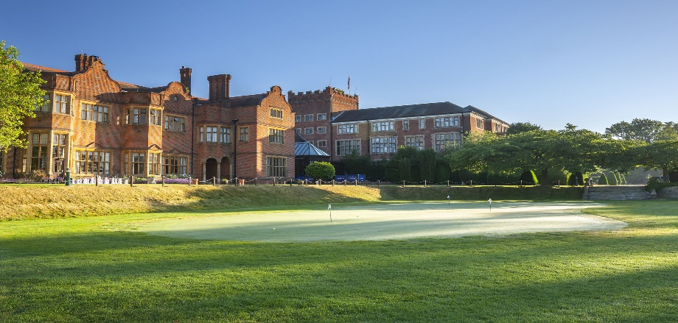

Pupil 6 - RETAIL
Morrisons, Hoddesdon

Pupil 7- CATERING/EDUCATION
Hailey Hall School

Pupil 8 - ENGINEERING
GW Cowler Precision engineering, Hertford

Pupil 9 - EDUCATION
Hailey Hall School

Pupil 10 - FOOD
Bubble Tea Boba, Stevenage

Pupil 11- ENGINEERING/ ADVERTISING
IMT Aviation, Saffron Walden

Pupil 12
Alternative Learning Provision (ALP)

Pupil 13
Hailey Hall School

